Activity1 HTML
Exercise1
1. What three HTML tags are used to describe the overall structure of a web page, and what do each of them define?
2. Where does the <title> tag go, and what is it used for?
3. How many different levels of headings does HTML support? What are their tags?
4. Why is it a good idea to use two-sided paragraph tags, even though the closing tag </p> is optional in HTML?
Exercise2
1. Define a form and give its function
2. Describe the main attributes of a form
3. What are the differences between the POST and the GET method? Put them in a table
4. Propose five elements of a form along with at least one attribute of each of them, then create a form having these elements. You can use a table for the presentation.
5. Create the form in the picture below and display your output
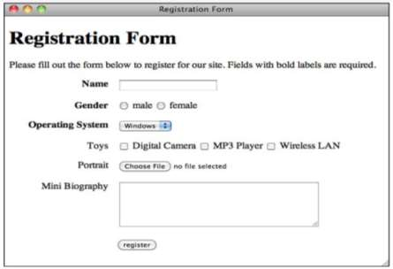

Exercise3
1. What are the basic parts of a table, and which tags identify them?
2. Which attribute is the most common attribute of the table tag, and what does it do?
3. Which attributes are used to create cells that span more than one column or row?
4. Which elements are used to define the head, body, and foot of a table?
5. Create a simple nested table (a table within a table) that contains three rows and four columns. Inside the cell that appears at the second column in the second row, create a second table that contains two rows and two columns.
6. Create a table that includes empty cells and verify that once you’ve done so, all the rows and columns line up as you originally anticipated.
7.Create the table below using html tags
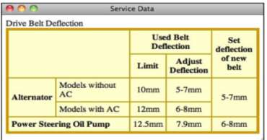

Exercise4
1. What two things do you need to create a link in HTML?
2. What’s a relative pathname? Why is it advantageous to use one?
3. What’s an absolute pathname?
4. What’s an anchor, and what is it used for?
5. Besides HTTP (web page) URLs, what other kinds are there?
6. Create two HTML pages and link them all together.
7. Create HTML page having a menu with links pointing in the same page to refer to some sections of your page.
Exercise5
1. Ordered and unordered lists use the <li> tag for list items. What tags are used by definition lists?
2. Is it possible to nest an ordered list within an unordered list or vice versa?
3. Which attribute is used to set the starting number for an ordered list? What about to change the value of an element within a list?
4. Use nested lists to create an outline of the topics covered in this book so far.

